NEW GENERATION CONTROL FOR DAILY ALUMINIUM SMELTER IMPROVEMENT
-
GENERATION 3 PROCESS CONTROL FOR POTLINES

Albert Mulder¹, Yashuang Gao¹, Dongfang Zhou², David S. Wong¹, Liu Ming², Pascal Lavoie¹, Mark P. Taylor¹, Xiaodong Yang²

¹ Light Metals Research Centre, The University of Auckland, Private Bag 92019, Auckland 1142, New Zealand
² Shenyang Aluminium & Magnesium Engineering & Research Institute Co. Ltd, Shenyang Branche of China, Aluminium International Engineering Co. Ltd, 184 Hepingbei Street, Shenyang, LN 110001 P.R.CHINA

Keywords: Process Control, Abnormality Detection, Root Cause Analysis, Corrective Actions

Abstract

Aluminium smelting is facing serious challenges in reducing energy consumption, increasing current efficiency and meeting constantly changing environmental expectations. Traditional control systems aim to achieve and maintain pre-determined smelter targets through adjusting process parameters, in order to compensate for changes in inputs, operations and special causes of variation. These control systems are not designed to remove the causes of variation and cannot address the pace and complexity of the challenges in the industry.

A new generation of process control, which not only brings the process back to the optimal operating range, but also improves it every day by early detection and diagnosis of the root causes of abnormalities is now required. Following earlier work by the authors in a number of smelters over the last 10 years, the present paper describes the development of a new generation process control, including a set of diagnostic tools and an embedded decision guidance process for people in management, supervision and operator roles within an aluminium smelter. The new generation process control has been tested successfully in a smelter. Its control architecture, implementation procedures and results are described.

Introduction

Almost all control systems currently in place at smelters all over the world can be categorized as ‘Generation 1’ process control. Essentially, Generation 1 process control can be defined as a reactive control system that is designed to bring the process back to its target settings by manipulating other variables. This usually leads to high levels of type I and type II control errors [1], resulting in either over-control (false alarms) or under–control (missed alarms) respectively. Therefore corrective actions from a Generation 1 process control can lead to greater process variation, rather than reducing it. Furthermore, when a pot becomes severely out of control, Generation 1 process control gives a lot of alarms, without any closed loop on control actions, decision or diagnostic guidance for the operators on how to fix the problem.

A large step in the design of process control systems by Light Metals Research Centre (LMRC) and others [2-4] resulted in ‘Generation 2’ process control in 2007-2008. The philosophy of Generation 2 process control is to diagnose and remove root causes when abnormalities are detected, by implementing corrective actions and avoiding compensatory responses (a common characteristic of Generation 1 process control). To date, only a few smelters have converted their control systems to Generation 2 process control as a result of this work. This is despite performance results of 1-2% increase in current efficiency (CE) and a 0.4 DC kWh/kg Al reduction in energy consumption [3], with potential for more improvements if all smelter operations and staff are properly incorporated into the control system. However, there are still significant weaknesses for Generation 2 process control as follows. Firstly, it is mainly a manual system for diagnosis and removal of process abnormalities, requiring intensive human interaction, investigation and intervention with the process. Being a manual system, there is little/no immediate feedback of the root causes of issues found on operational procedures/factors (e.g. quality of following the anode setting procedure) and therefore the link between process performance and management system is weakened. Furthermore, the alumina feeding regulation is not sensitive to alumina dissolution, resulting in large amounts of alumina being added to pots that cannot be dissolved, causing sludge. This is still a major issue in Generation 2 process control, especially where alumina quality or pot condition varies out of the optimum range.

LMRC and Shenyang Aluminium and Magnesium Design and Research Institute (SAMI) have developed a new generation process control for aluminium smelting technology to eliminate these weaknesses and achieve the challenging performance targets, especially for high amperage potlines such as 400kA and 500kA. The ‘Generation 3’ process control philosophy was refined and developed further on the basis of Generation 2 process control.

Generation 3 process control integrates all major processes that are linked to the smelter’s process control, including early detection and diagnosis of process abnormalities with additional sensors, guided root cause analysis and automated control of corrective actions. The smelter management control system in Generation 3 process control also integrates human actions and observations from process control and operations staff. The new generation process control has now been tested successfully in a smelter.

There is a significant difference between a traditional level 1 pot controller that is available in the industry, and the Generation 3 Potline Control System. In the new Generation 3 process control, the level 1 pot controller provides only basic control functions for each individual pot, such as feed control, voltage control and providing functions for operational actions like metal tapping, anode change and beam raising. However the Generation 3 process control system is much wider in scope, focusing not only on individual pots, but also on groups of pots and entire potlines.

Generation 3 process control contains a more sophisticated control arsenal at level 2, i.e. the supervisory level of control, which aims to diagnose the underlying variation in each pot and groups of pots. Advanced multivariate techniques and mass and energy balancing strategies are employed to diagnose and address the root causes of detected problems and to prevent the pot from going out of control when an abnormality is detected. The supervisory system fuses this higher level of process control, using combined analysis of level 1 data, operational data and observations recorded routinely by the potline staff. This allows automated and rapid correction of abnormalities before they cause damage to the pot performance

Generation 3 Process Control

Architecture and Philosophy

Figure 1 shows the basis of the architecture and philosophy of Generation 3 process control which has evolved from Generation 2 process control [3]. The concept was quite successful in terms of improvements to CE and power consumption. However the existing architecture and philosophy of Generation 2 process control had some weaknesses as mentioned previously. To correct these weaknesses new features were added to the existing architecture and philosophy.

One important feature is the ability to sense the pot state continuously and use a guided diagnosis system to identify the specific cause when an abnormality has been detected. Another feature is the ability of the system to interact with humans to allow the system to address the root cause. There is also more emphasis in the new system on connecting process and operational performance feedback to the existing management process.

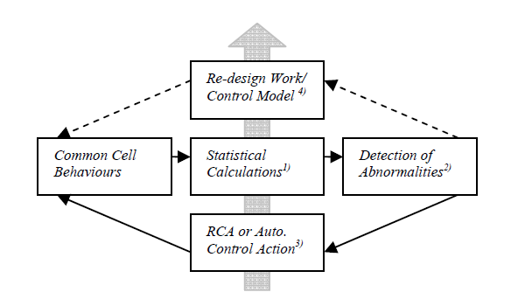
Figure 1. An illustration of the control architecture of Generation 2 control system [3].

Within the process control a new alumina feed control philosophy has been adopted, in which, alumina feeding is controlled based on sensed dissolution rate. This addresses the fundamental alumina feeding regulation problem present in all previous control systems – a total reliance on alumina concentration to determine when to feed more alumina.

In addition to the architecture represented in Figure 1, the Generation 3 system uses a ‘Four-Square Pot State Indicator’ with four color states to guide the interaction between the control system and humans on detection of abnormalities (‘Abnormality Detection’), analysis of root causes to these abnormalities (‘Root Cause Analysis’ or RCA) and corrective actions.

Detection Tools

Generation 3 process control continuously evaluates the state of each pot or group of pots by using statistical detection tools including hard limit detection, CUSUM mass and energy imbalance detection, Hoteling’s T², feature matching and others.

The detection tools used in Generation 3 process control are built and tested with parameters specific to a smelter. The tools are run 24 hours a day, 7 days a week continuously or punctually when certain operational events occur. All functions for detecting abnormalities operate continuously.

Abnormality Detection

An abnormality in Generation 3 process control can be defined as one pot state or a combination of multiple pot states that lead to a well-defined sequence of automatic and manual checks called pigeonholing that lead to an efficient determination of the root cause and selection of the best known corrective actions. These actions are updated by feedback from their results on the process periodically.

Generation 3 process control focusses on the detection of abnormalities of three main and related pot issues. ‘Feed issues’ focus on the detection of alumina feed problems with alumina dissolution, feeder hardware, cover practices or bath transfer practice. ‘Noise issues’ focus on the anode and cathode-related problems that cause instability on a pot. ‘Heat balance issues’ focus on problems in the short-term heat balance state of the pot by sensing liquidus and bath superheat, or alternatively bath composition and temperature (if liquidus or superheat sensors are not implemented).

Generation 3 process control also has a built-in ‘escalation’ mechanism, which allows the system to prioritize more serious pot issues if they occur. When this happens, the system automatically adjusts the set of automatic and manual checks, the appropriate corrective actions and the level of notification of management.

The system allows potroom managers to be well informed about persistent or widespread control problems in the process before these problems cause deterioration of potline performance. This information strategy creates a new pre-emptive control capability in the organization.

Root Cause Analysis

Once an abnormality is detected, there is a clear guideline on the pot’s automated checks and manual checks that need to be completed. As mentioned above, Generation 3 process control reduces the number of manual checks to the amount required to find the root cause of the problem that was detected. Generation 3 process control is designed in such a way the biggest process driver will determine the corrective actions.

Corrective Actions

Every detected root cause of an emerging abnormality has a plan with associated corrective actions associated to it, describing how to correct or eliminate the problem by directly addressing that cause. This is in contrast to Generation 1 systems that apply compensating actions which over-control the process (e.g. by adding excessive AlF₃ additions for pots with high temperature) and exacerbate the condition of the pot. While blocking of compensatory actions exists in Generation 2 process control, a unique feature of Generation 3 is the capability of guiding the corrective actions it prescribes. If a plan with corrective actions is unsuccessful, the corrective actions are cancelled and the system reevaluates either the actions or the abnormality itself to diagnose a different root cause if necessary.

Four-Square Pot Status Indicator

Following one of the guiding principles of the Generation 3 process control philosophy – Simplicity and Transparency – a simple ‘Four-Square’ color system (shown in Figure 2) is one of the major features of the process control system. This not only indicates the condition of pots in a visual and effective way, but also illustrates a number of Generation 3 functions, such as abnormality detection and tracking mechanisms. This ‘Four-Square’ system accommodates the following main functions:
- Indicating pot status – whether a pot (i) has an abnormality detected, (ii) an active plan with corrective actions, or (iii) is running normal.
- Tracking mechanisms – keeps track of the pot state (color).
- Prioritization system – abnormalities are priority driven, i.e. the abnormality with the highest priority will be taken for further analysis.

The Four-Square Status indicator in the Generation 3 process control is also used to periodically evaluate the control system’s effectiveness as a whole (performance of the system in detecting, removing and/or correcting causes of variation) and leads to improvement of the overall function of the control system.

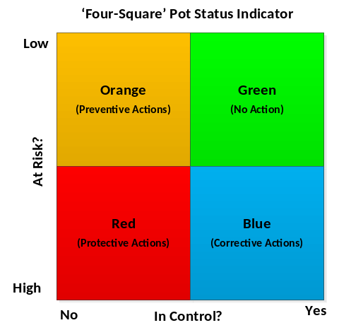
Figure 2. An illustration of the 'Four-Square Pot status indicator.

Methodology for Evaluating Generation 3

Two methodologies were used to evaluate the Generation 3 process control system, each encapsulating separate but linked evaluation areas. The first area evaluated was the improvement to process performance on a test group of pots in terms of CE, decrease in anode effects and power consumption. The second area evaluated was the effectiveness of the Generation 3 process control software meeting control objectives in terms of detecting pot issues, finding root causes and resolving these issues.

Both of these evaluation methods were used for evaluating the impact of using Generation 3 process control at a smelter. Several statistical problems are of particular relevance for smelters in this regard.
- Taking into account the global performance variation of all pots or even a section of pots. This problem is solved by introducing a control group of pots experiencing the similar conditions (raw materials, operations, etc) at the same time as the test group of pots.
- The comparison with a control group located outside the influence sphere of the Generation 3 system, and having very different operational characteristics, possibly better performing and leading to a better starting point from an absolute data analysis point.

The method that was adopted to address these issues is ‘BACI’ (Before After Control Impact). This model is capable of showing whether or not a system or process change is significant through first removing the natural variation that exists between pots [5].

To test whether the Generation 3 process control system architecture, philosophy and implementation worked according to design and was able to function effectively another methodology was used. A modified ‘Signal Detection Analysis’ model [6] (adapted from [7]) was used to evaluate the effectiveness of the Generation 3 control system, as shown in Figure 3.

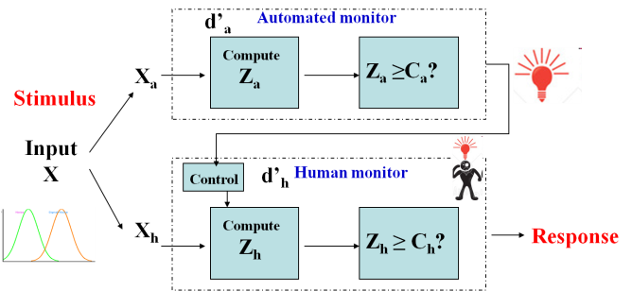
Figure 3. A detection model with system and human monitors [6].

Abnormalities automatically detected by the system were picked up by the experimenters. After closer examination of the tools used to capture each detected abnormality, the experimenters could assess the detection as either a correct hit (HIT), missed hit (MISS) or a false hit (FALSE). The same procedure was used to evaluate the chosen root cause analysis and decision on the correct corrective actions.

Evaluation Results

Based on the above methodology, two sets of results will be discussed. First the result of the signal detection analysis of Generation 3 process control system is discussed in terms of detecting problems, determining the root cause correctly and solving the problem within specified time limits. Secondly the pot performance of the whole test group of pots using Generation 3 control is presented in terms of CE, anode effects and energy consumption.

Signal Detection Analysis

Signal Detection Analysis was performed to evaluate the effectiveness of the Abnormality Detection data, Root Cause Analyses (RCA) and on the corrective actions applied. The results identified are as follows.

A trial of Generation 3 process control at the smelter was implemented on a test group of 8 pots. Adjacent to the test group, a group of 8 pots was selected as a control group to evaluate the impact of the new generation process control.

Of all abnormalities detected and investigated, 48% were assessed as correct HITS, 29% were FALSE detections and 23% were MISSED detections (detected by people, but not by the system). Figure 4 shows a graphical representation of the Signal Detection Analysis on Abnormality detection. The most prevalent abnormalities detected and investigated were high frequency noise abnormalities and high CUSUM Feed Abnormalities. This shows the ability of the Generation 3 process control abnormality detection system to reflect the most common issues at the smelter at which the experiment was conducted.

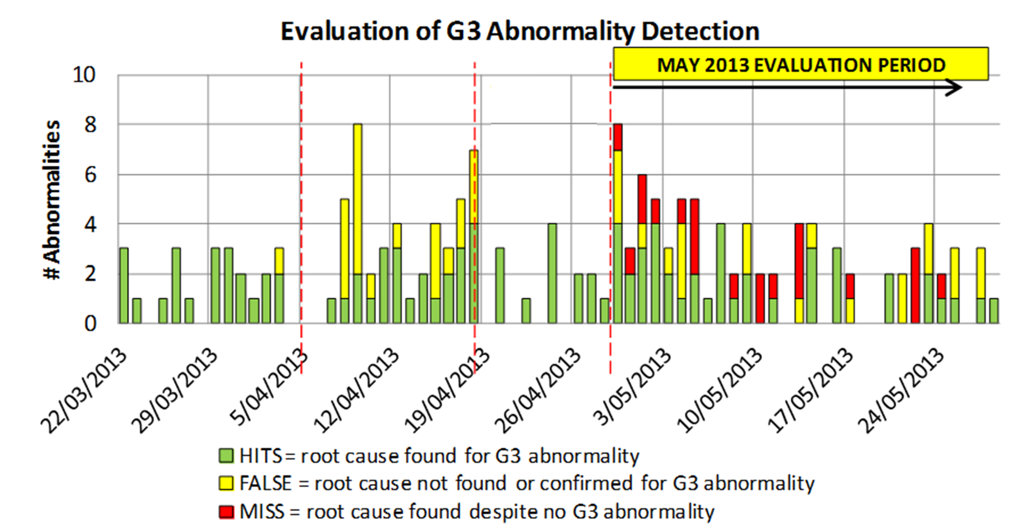

Figure 4. No. of HITS, FALSE detections and MISSED detections for evaluating the Gen 3 system’s Abnormality Detection

In total, 41 abnormalities during the test period were used to assess the effectiveness of the Root Cause Analysis (RCA) process. The assessment found that for 75% of abnormalities, the RCA process found the correct root cause (HIT). However in 25% of abnormalities, the root cause found was not correct (MISS). Figure 5 shows the root causes identified by the Generation 3 system in relation to HITS and MISSES.

In the April and May test period, 49 corrective action sequences were attempted. First time diagnoses/corrective action sequence had a success rate of 67%. Subsequently the system picked up abnormalities which were not successfully diagnosed and/or corrected (the 33% MISSES) and escalates their status to potline staff with new recommendations for removing their causes.

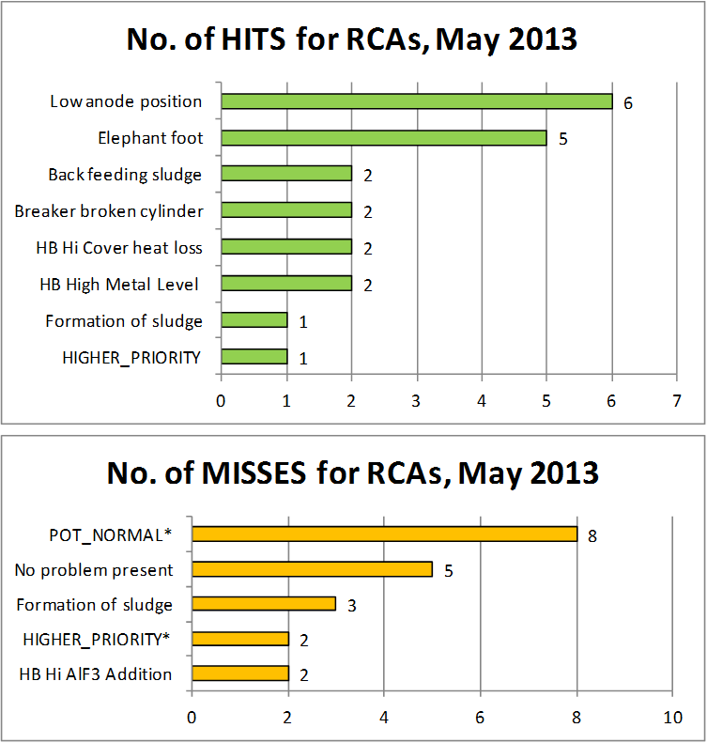

Figure 5. No. of HITS and MISSES for RCA’s identified.

Many of these persistent abnormalities are structural smelter problems associated with poor quality anodes or mechanical failures of components such as feeders. These structural problems may take more time and staff input to address, and therefore present initially as MISSES on the control system

While very reasonable HIT rates were found in the initial smelter testing of Abnormality Detection, RCA and control action processes within the Generation 3 system, further significant improvements can be made through further tuning of system parameters and settings. By increasing the effectiveness of each process, the system has the potential to make even greater gains in pot performance.

Pot Performance

Figure 6 shows the trend of CE and power consumption on the test group of pots before and during the trial period.

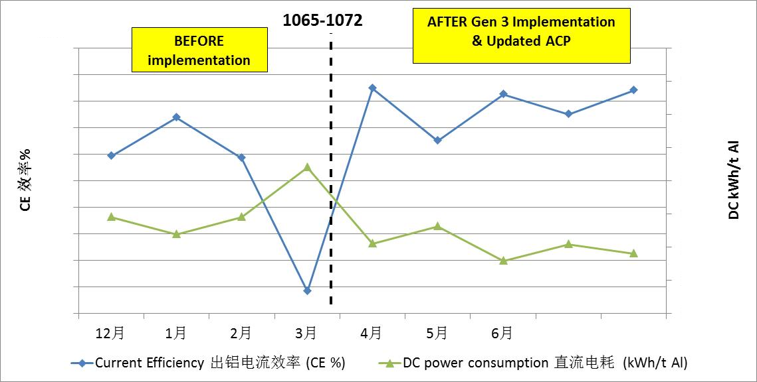

Figure 6. A graphic representation of CE and power consumption, “before” and “after” implementation of Generation 3.

The new alumina feed control philosophy had a dramatic lowering impact on the number of anode effects. The cathode voltage drop during the trial period also dropped, indicating cleaner cathode surface. Figure 7 shows the number of anode effects per day. The yellow arrow points to the starting point of the new feed philosophy.

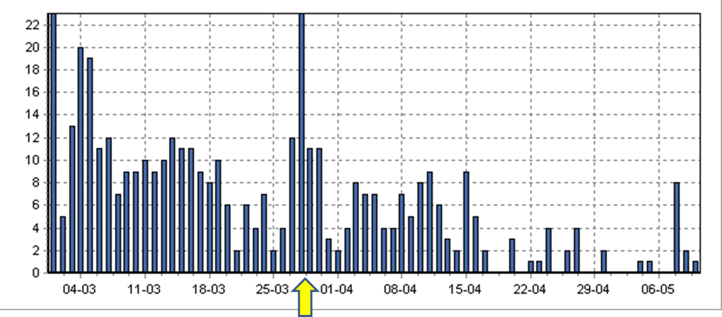

Figure 7. A graphic representation of the “Before” and “After” in terms of Anode effects

Overall, the following performance improvement results were achieved through implementation of Generation 3 control on the test group of pots, i.e. comparing “after” vs. “before” the trial:
- Current Efficiency, CE: ↑1.3%
- DC power consumption: ↓355kWh/T Al
- AE Frequency: ↓96%
- Noise Level: ↓27%
- The control group of pots itself did not improve. This group was not using the new Generation 3 process control system.

Below, two case studies demonstrating the usage of Generation 3 process control in the smelter are discussed.

Case Study 1

In the first case study, the pot had undergone an anode change operation several hours earlier, after which the pot exhibited a high level of noise and instability (Figure 8). In normal circumstances, a certain level of noise for short periods after anode setting is considered acceptable. However in this case the noise remained above a certain threshold level for more than 18 hours. Causes of noise can be categorized into either anode-related issues or cathode-related issues.

The new control system has the ability through noise frequency analysis to distinguish between anode related issues and cathode related issues. In this case the control system was able to pinpoint a dominant high frequency noise feature which indicated an anode related issue.

The control system automatically generates a checklist for the operator, helping the operator to systematically diagnose the root cause of the problem. It was found that one anode had a high fluctuating current draw. This finding was noted down on a checklist and entered finally into the new control system. After the root cause was established a work order was placed for the crew to raise the problem anode. As can be seen in Figure 8 (yellow shaded area), after adjustment of the anode the pot returned to normal.

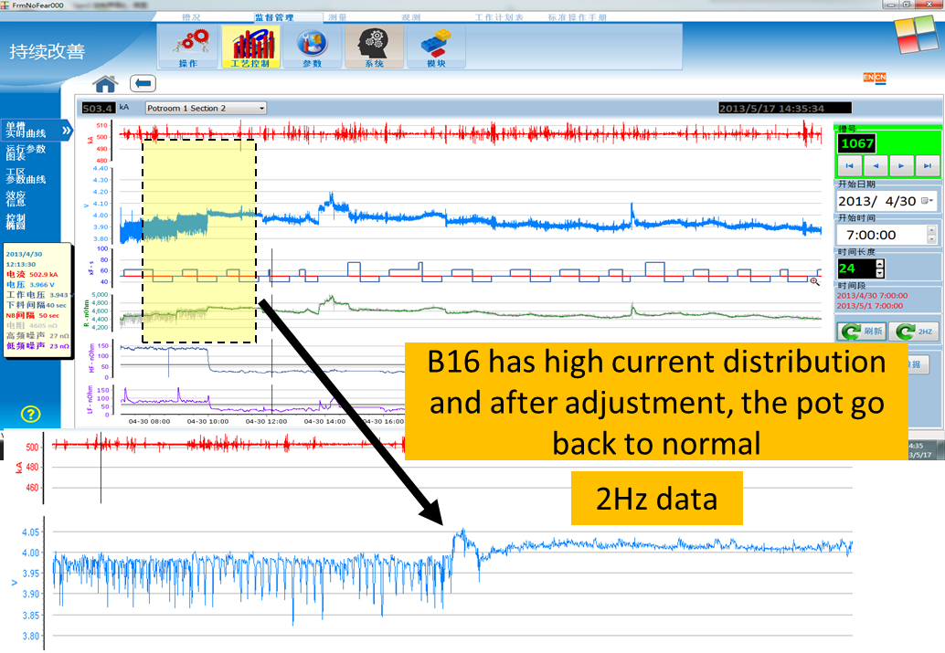

Figure 8. Shows the pot trace of the detected abnormality and the point at which the root cause was addressed.

Case Study 2

In the second case study (Figure 10), a vast amount of overfeeds suddenly occurred, triggering an abnormality in the Generation 3 process control system. Clearly, an immediate problem had emerged and the pot seemed to have been overfed by the governing feeding strategy.

The new control system was able to identify the sudden change in feed behavior by monitoring the alumina CUSUM feed every 5 minutes. As shown in Figure 10, the alumina CUSUM increased and breached a predefined limit. A high CUSUM indicates that a pot is getting excessive feed by the pot controller.

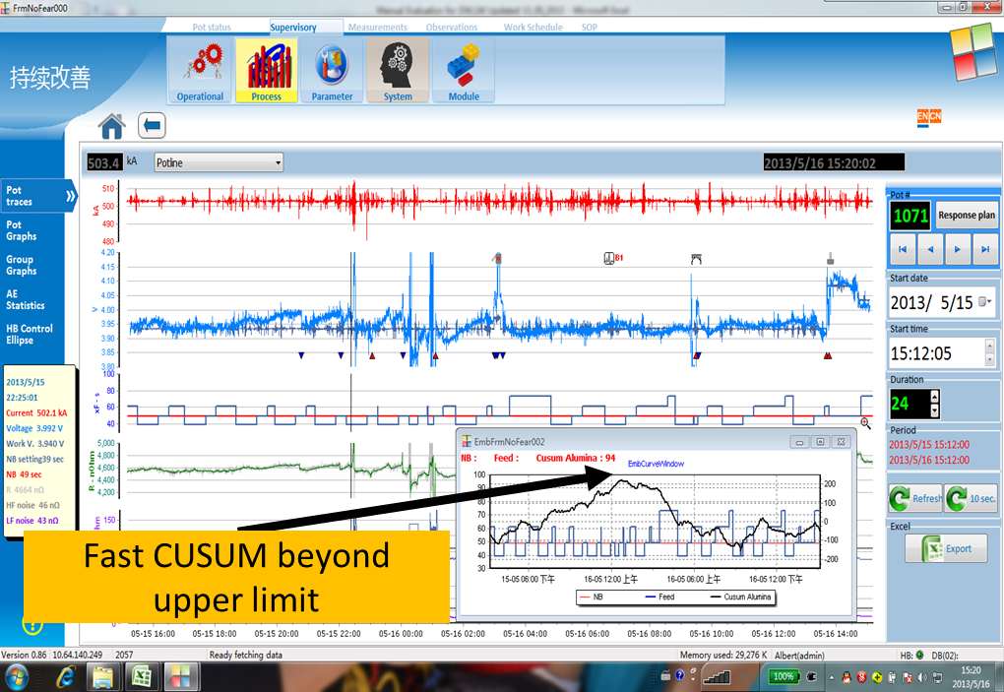

Figure 9. Generation 3 HMI display on CUSUM feeding

Based on this specific abnormality the control system automatically generated a new checklist for the operator (different from Case Study 1), helping in diagnosing the root cause of the problem.

As can be seen in Figure 11 it was found that one of the feeder holes was completely blocked preventing the alumina from going into the pot. Although opening the blocked feeder hole is an actionable cause, the real root cause was a leaking feeder. After putting this crucial information into the Generation 3 system, two work orders were issued. One work order was issued to a group of operators to open the feeder hole and another work order was issued to the maintenance department to fix the leaking feeder. The problem was solved by opening the feeder hole as shown by the alumina CUSUM graph in Figure 10 returning back to normal.

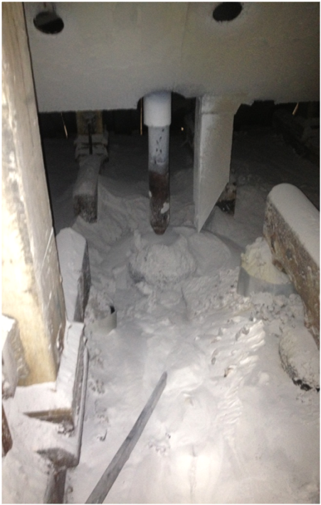

Figure 11. Root Cause of the problem identified – a blocked feeder hole cause by a leaking feeder

Conclusion

It should be noted that the currently implemented version of the Generation 3 process control is the first implemented in a smelter. However, as shown by the results above, Generation 3 process control is capable of detecting most common issues of the smelter and identifying and correcting the root causes. The longer term benefit of preventing massive over-feeding of alumina, large numbers of anode effects, pots overheating, and other common out of control situations has far-reaching impacts on the stability of the smelter and on the rate at which performance can be improved over time.

In the short term, the most significant value of the Generation 3 process control for potlines is very early detection of abnormalities and effective removal of the root cause (as the case studies have shown). The effectiveness of the Generation 3 process control system and the performance of the process are closely related. Although the overall performance can be improved even more by tuning the Generation 3 process control system, it should be noted that the integration of the Generation 3 control system into the management system will give an additional performance gain due to the unlocking of longer term performance improvements.

Acknowledgements

Many people have contributed in many ways to make the Generation 3 process control successful. The authors would like to acknowledge the rest of the team for their contribution to the system development, testing and implementation: Yong Fu, Kefu Cha, Xinzhong Tang, Nursiani Tjahyono, Jenny Hung, Matthew Clarke, Tim, Harton, Matthew Barrett, Wei Liu, Ronny Etzion, Zhang Fenping, Hu Xiaolong and Huang Shaomin.

References

[1] M.P. Taylor and J.J.J. Chen, “Advances in Process Control for Aluminium Smelters”, Materials and Manufacturing Processes, 2007, Vol. 22 (7), 947-957.
[2] M.A. Stam, M.P Taylor and J.J.J. Chen, A. Mulder, R. Rodrigo, “Common Behaviour and Abnormalities in Aluminium Reduction Cells”, TMS Light Metals 2008, 309-314.
[3] M.A. Stam, M.P Taylor, J.J.J. Chen, A. Mulder and R. Rodrigo, “Development of a multivariate process control strategy for aluminium reduction cells”, TMS Light Metals 2009, 311-315.
[4] M.A. Stam “The pursuit of causality in multivariate statistical control of aluminium smelting cells”, Chemical and Materials Engineering, PhD Thesis, The University of Auckland.
[5] Stephen Rutledge, “Statistical methods for use in the aluminum smelting industry”, TMS Light Metals 2008, 325-327.
[6] Yashuang Gao, Mark P. Taylor, John J.J. Chen and Michael J. Hautus, ”Human factors in operational and control decision making in aluminium smelters”, TMS Light Metals 2011, 605-609.
[7] R. D. Sorkin and D. D. Woods, “Systems with human monitors: A signal detection analysis”. Human-Computer Interaction, 1985, 1:49–75.

